JAVA ASSIGNMENT-7 (16/11/2018)

1)Write a java program to copy the characters of an array in reverse into another array

package raj;

public class CharRevArray
{
public static void main(String[] args)
{
char ch[]={'a','f','y','g'};
char b[]=new char[ch.length];
int j=0;

for (int i=ch.length-1;i>=0;i--)
{
b[j]=ch[i];
j++;
}
for(j=0;j<b.length;j++)
{
System.out.println(b[j]);
}
}

}

Output:
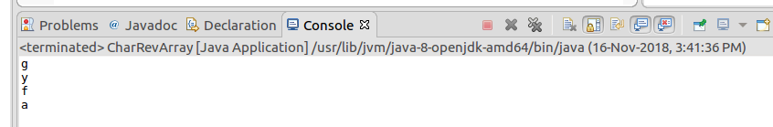

2)Write a java program to reverse thw given string

package raj;

public class StringRev {

public static void main(String[] args) {
String s="klmnop";
char ch[]=s.toCharArray();
{
int i;
System.out.println("the character array is ");
for (i = 0; i < ch.length; i++)
{
System.out.println(ch[i]);
}
int j=0;
char a[]=new char[ch.length];
for(i=ch.length-1;i>=0;i--)
{
a[j]=ch[i];
j++;
}
System.out.println("the reverse of character array is ");
for(j=0;j<a.length;j++)
{
System.out.println(a[j]);
}
String s2=new String(a);
System.out.println("the reverse string is");
System.out.println(s2);
}

}

}

Output:
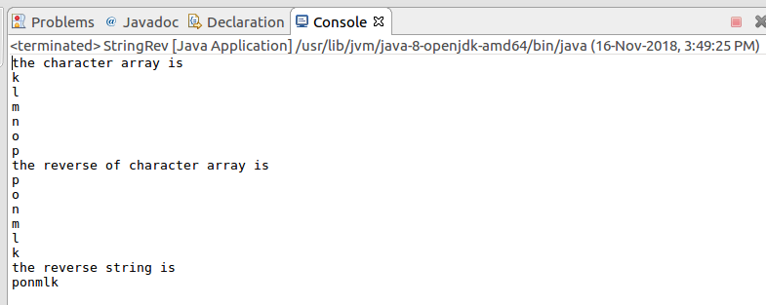

3)Write a java program to find the frequency of eac character of the given string

package raj;

public class Frequecy {

public static void main(String[] args) {
String s="aaabbaacccbbaab";
char ch[]=s.toCharArray();
int acount=0,bcount=0,ccount=0;
for(int i=0;i<ch.length-1;i++)
{
if(ch[i]=='a')
{
acount++;
}
else if(ch[i]=='b')
{
bcount++;
}
else if(ch[i]=='c')
{
ccount++;
}
}
System.out.println("char frequency");
System.out.println("-----------------");
System.out.println("a "+acount);
System.out.println("b "+bcount);
System.out.println("c "+ccount);
}

}

Output:
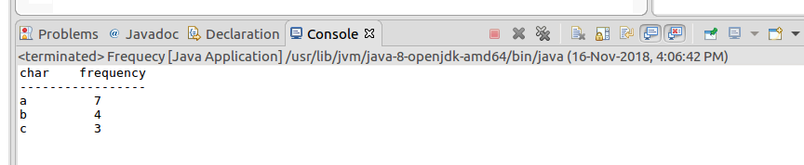

4)Write a java program to identify location of vowels of the given string(I am not a good man)

package raj;

public class Vowels {

public static void main(String[] args) {
String d="I am not a good man";
char ch[]=d.toCharArray();
for(int i=0;i<ch.length;i++)
{
if(ch[i]=='a'||ch[i]=='e'||ch[i]=='i'||ch[i]=='o'||ch[i]=='u')

{
int z=d.indexOf(ch[i]);
System.out.println("The position of "+ch[i]+" is "+z);
}
}
}

}

Output:
